Data Structure Assignment-1

NAME : Shaikh Muaz Khalid

Roll no. : 22

PRN no. : 12111218

Insertion Sort:

CODE:

#include <stdio.h>

#include <string.h>

struct classroom

{

int Roll_no;

int total_marks;

char student_Name[70];

};

int P = 0;

void assign(struct classroom * f ,int first,struct classroom * g,int last){

f[first].total_marks = g[last].total_marks;

f[first].Roll_no = g[last].Roll_no;

strcpy(f[first].student_Name,g[last].student_Name);

P++;

}

void display(struct classroom * arr, int n) {

int i;

for(i=0;i<n;i++){

printf("Student's Student Name: %s\n", arr[i].student_Name);

printf("Student's Roll no: %d\n", arr[i].Roll_no);

printf("Student's Total Marks: %d\n", arr[i].total_marks);

}

}

void insertionSort(struct classroom * arr, int n) {

for (int i = 1; i < n; i++) {

struct classroom tmp[1];

assign(tmp,0,arr,i);

int k = i - 1;

while (tmp[0].Roll_no < arr[k].Roll_no && k >= 0) {

assign(arr,k+1,arr,k);

--k;

}

assign(arr,k+1,tmp,0);

}

}

int main() {

int i, n;

printf("Number of students in class: ");

scanf("%d",&n);

struct classroom arr[n];

for(i=0;i<n;i++){

printf("Enter %d Student Name: ", i+1);

scanf("%s",&arr[i].student_Name);

printf("Enter %d Students Roll no: ", i+1);

scanf("%d",&arr[i].Roll_no);

printf("Enter %d students Total Marks: ", i+1);

scanf("%d",&arr[i].total_marks);

}

printf("NOT Sorted:\n");

display(arr, n);

insertionSort(arr, n);

printf("Sorted with key as student roll no.:\n");

display(arr, n);

printf("Number of Steps performed are %d\n",P);

}

Input:

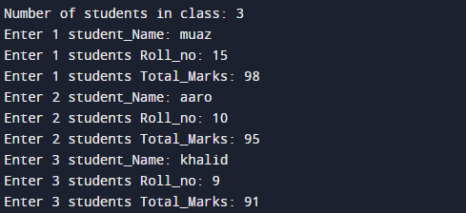

Output:

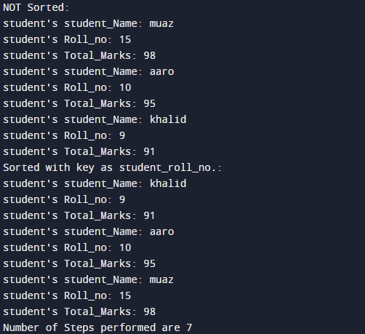

Quick Sort:

CODE:

#include<stdio.h>

#include <string.h>

struct classroom

{

int Roll_no;

int Total_Marks;

char student_Name[70];

};

int n = 0 ;

void swap(struct classroom * f ,int first,int last){

int temp;

char tempchr[70];

temp = f[first].Total_Marks;

f[first].Total_Marks = f[last].Total_Marks;

f[last].Total_Marks = temp;

temp = f[first].Roll_no;

f[first].Roll_no = f[last].Roll_no;

f[last].Roll_no = temp;

strcpy(tempchr,f[first].student_Name);

strcpy(f[first].student_Name,f[last].student_Name);

strcpy(f[last].student_Name,tempchr);

}

void quicksort(struct classroom * f ,int first,int last){

int i, k, pivot, temp;

if(first<last){

pivot=f[first].Roll_no;

i=first;

k=last;

while(i<k){

while(f[i].Roll_no<=pivot&&i<last){

i++;

}

while(f[k].Roll_no>pivot){

k--;

}

if(i<k){

swap(f,i,k);

n++;

}

}

swap(f,k,first);

n++;

quicksort(f,first,k-1);

quicksort(f,k+1,last);

}

}

int main(){

int i, count;

printf("Number of students in class: ");

scanf("%d",&count);

struct classroom arr[count];

for(i=0;i<count;i++){

printf("Enter %d Students Roll_no: ", i+1);

scanf("%d",&arr[i].Roll_no);

printf("Enter %d Student Student_Name: ", i+1);

scanf("%s",&arr[i].student_Name);

printf("Enter %d Students Total_Marks: ", i+1);

scanf("%d",&arr[i].Total_Marks);

}

quicksort(arr,0,count-1);

printf("Sorted with key as Student_roll_no.: \n");

for(i=0;i<count;i++){

printf("Student's Student_Name: %s\n", arr[i].student_Name);

printf("Student's Roll_no: %d\n", arr[i].Roll_no);

printf("Student's Total_Marks: %d\n", arr[i].Total_Marks);

}

printf("Number of swaps performed are %d\n",n);

return 0;

}

Input:

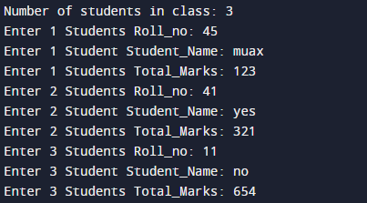

Output:

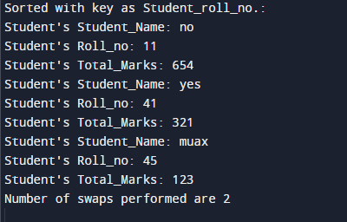

Thank You :)